**MONTANA District**

**Eagle Wings Motorcycle Association**

**“Pulling The Bear Tooth”**

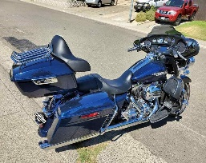



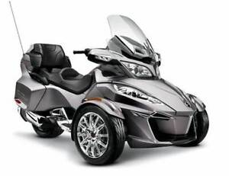  
The Montana District of The Eagle Wings Motorcycle Association would like to invite you to come join us at our 2024 Rally on July 25th, 26th and 27Th, 2024 in Laurel Montana. Come ride the Bear Tooth Highway and Chief Joseph Highway along with other adventurous roads. There will be lots of fun, great camaraderie, light show and prizes. For more information check out our website at <http://ewma-montana.org> or our Facebook page Montana District Two and Three Wheeled Motorcycle Group or call 1-406-546-3586. We do not care what you ride or how many wheels it has two, three or four. We are about having fun and riding.