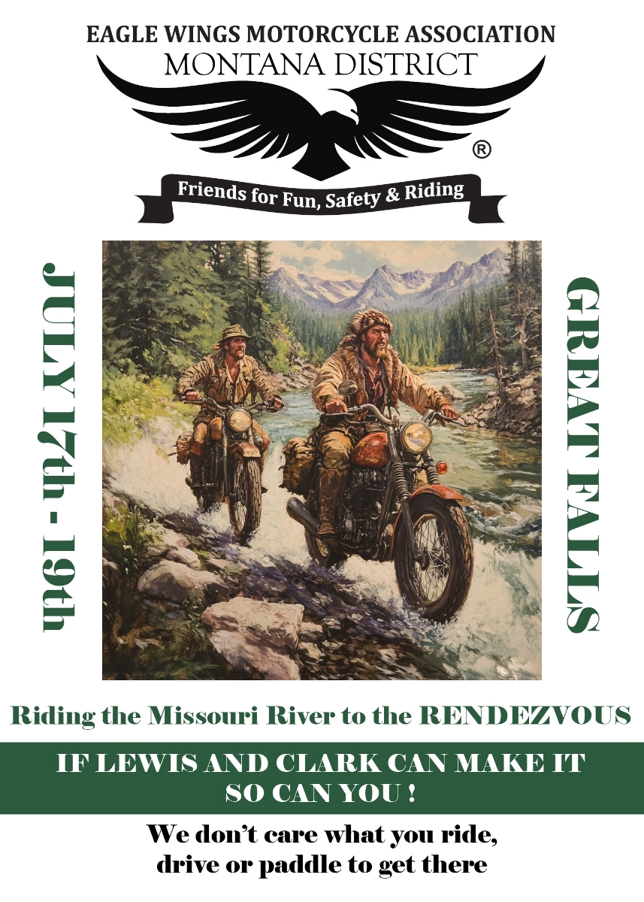


EWMA MONTANA DISTRICT IS PUTTING ON A RENDEZVOUS IN GREAT FALLS AT THE HERITAGE INN JULY 17TH THRU 19TH. LOTS OF FUN, POKER RIDE AND DRAWINGS FOR PRIZES. DINNERS EACH NIGHT. FOR MORE INFORMATION CHECK OUT OUR FACEBOOK AT MONTANA DISTRICT EWMA TWO AND THREE WHEELED MOTORCYCLE GROUP or CONTACT WILLIE 406-546-3586 AT GRAMPSWIGGLY@AOL.COM or website http://ewma-montana.org . REGISTRATION FORM ON THE FACEBOOK PAGE.
Website
Facebook

